Documentation of

HotelRevAI – AI-Driven Revenue Analysis for Hotels

Submitted By: Gaurav Raipurkar
Submitted To: Janani mam

Table of Contents

1. Project Overview
2. Objectives
3. Methodology and Tools
4. Module 1: Data Modelling and Ingestion
5. Module 2: Revenue KPI Analysis
6. Visualisation and Analysis
7. Insights and Findings
8. Conclusion

Project Overview

The HotelRevAI project is designed to help hotels transform raw booking data into meaningful and actionable insights. Using Microsoft Excel, Power BI, Power Query, and DAX, the system enables hotel management to analyze performance across multiple branches, room types, and customer segments.
This analytical solution focuses on identifying trends in occupancy, pricing efficiency, and seasonal performance over a three-year dataset (2020–2025). It serves as a practical model for how hotels can leverage data-driven intelligence to make better pricing, marketing, and operational decisions.

Objectives

• To clean and prepare hotel booking, customer, and room data.
• To design a Star Schema model integrating fact and dimension tables.
• To calculate and visualise major KPIs such as Occupancy %, ADR, and RevPAR.
• To identify booking trends by branch, season, and customer type.
• To generate insights for improving hotel revenue and operational strategies.

Methodology and Tools

Tools Used:
- Microsoft Excel
- Power Query
- Power BI
- DAX
- Data Modelling

Methodology Steps:
- Data Collection and Cleaning
- Schema Design
- Transformation and Calculations
- Visualisation and Reporting
- Insights Generation

- Module 1: Data Modelling and Ingestion

The first module of HotelRevAI focuses on building a reliable and analytical data foundation for the entire project. The goal was to design a complete hotel booking dataset covering the period 2020 to 2025, integrate it into Power BI, and create a clean star schema structure suitable for business intelligence and revenue analysis.

Dataset Creation
A comprehensive dataset was created in Excel, comprising five interconnected sheets: Hotel Booking, Customer, Branch, Room, and Date.
Each sheet holds distinct information essential for the model:
- The Hotel Booking sheet records all booking transactions, including customer, room, branch, and date references.
- The Customer sheet stores guest details such as name, gender, age, nationality, and customer type (New or Repeat).
- The Branch sheet captures the details of each hotel branch, including branch ID, branch name, city, state, and total rooms.
- The Room sheet lists all available room types (Standard, Deluxe, Premium, Suite) along with their base prices and occupancy capacities.
- The Date sheet serves as the time dimension, containing date ID, full date, day, month, year, quarter, and weekend/weekend flags for time-based analytics.

These five tables were designed to interconnect through unique IDs, forming the foundation for relational modelling inside Power BI.

Excel-Based Data Preparation

Before loading data into Power BI, several calculated columns were added to the Hotel_Booking sheet using Excel formulas to derive important analytical attributes. The following steps summarise the process:

Duration: The length of each stay was calculated using
=I2-H2,
which subtracts the Check-in Date from the Check-out Date to get the number of nights stayed.

Price per Night: Room rates were dynamically fetched from the Room sheet using
=IFERROR(VLOOKUP(TRIM(M2),Room!C:F,4,FALSE),5000).
This ensures accurate pricing for each room category and sets a default value of ₹ 5000 if the lookup fails.

Total Price: The total booking amount was computed with
=Q2*J2,
multiplying the duration by the nightly rate.

Stay Type: To categorise guests based on how long they stayed,
=IFS(J2=1,"Day Use",J2<=3,"Short Stay",J2<=7,"Extended Stay",J2>=8,"Long Stay")
was applied, creating meaningful groupings for reporting.

Room Type Booked: This column maps stay duration to a room category using
=IF($J2<=3,"Standard",IF($J2<=6,"Deluxe",IF($J2<=10,"Premium","Suite"))).

Purpose: Guest intent was derived through
=IF(ISNUMBER(SEARCH("Suite",D2)),"Honeymoon",IF(Q2>10000,"Business",IF(Q2>5000,"Conference",IF(J2>=8,"FamilyVacation","Other")))),
which classifies bookings into purposes like Honeymoon, Business, or Family Vacation.

These computed columns transformed raw booking records into actionable analytical fields that could later feed Power BI visualisations.

Integration and Star Schema Design

Once all calculations were completed, the dataset was imported into Power BI Desktop through Power Query. During the ingestion stage, data types were verified, redundant fields removed, and all tables were connected using one-to-many relationships to form a Star Schema.

The central Fact Table (Fact_Booking) stores transactional data such as booking ID, customer ID, room type, branch ID, date ID, duration, price per night, total price, stay type, and star rating.

The supporting Dimension Tables — Dim_Customer, Dim_Room, Dim_Branch, and Dim_Date — provide descriptive attributes for slicing and filtering analysis.

This star schema ensures optimal query performance and easy integration with DAX measures in later modules.

Visualisation References

Figure 1: Excel Hotel_Booking sheet displaying calculated columns.

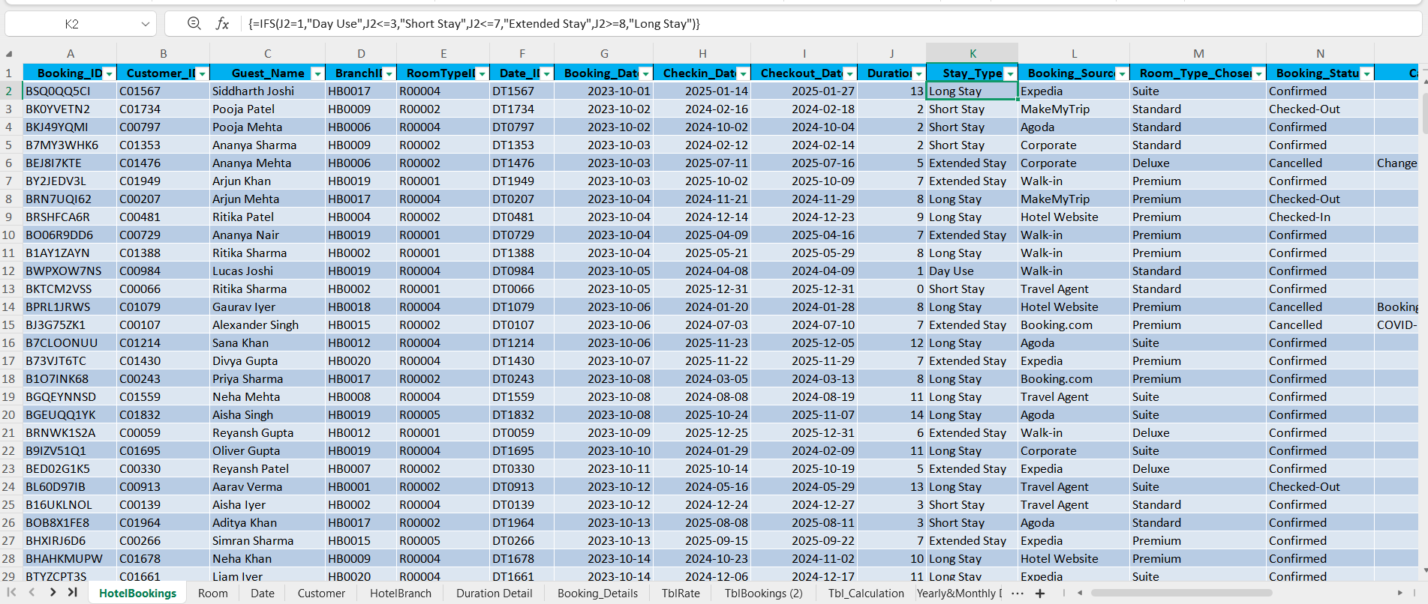

Figure 2: Power BI Star Schema

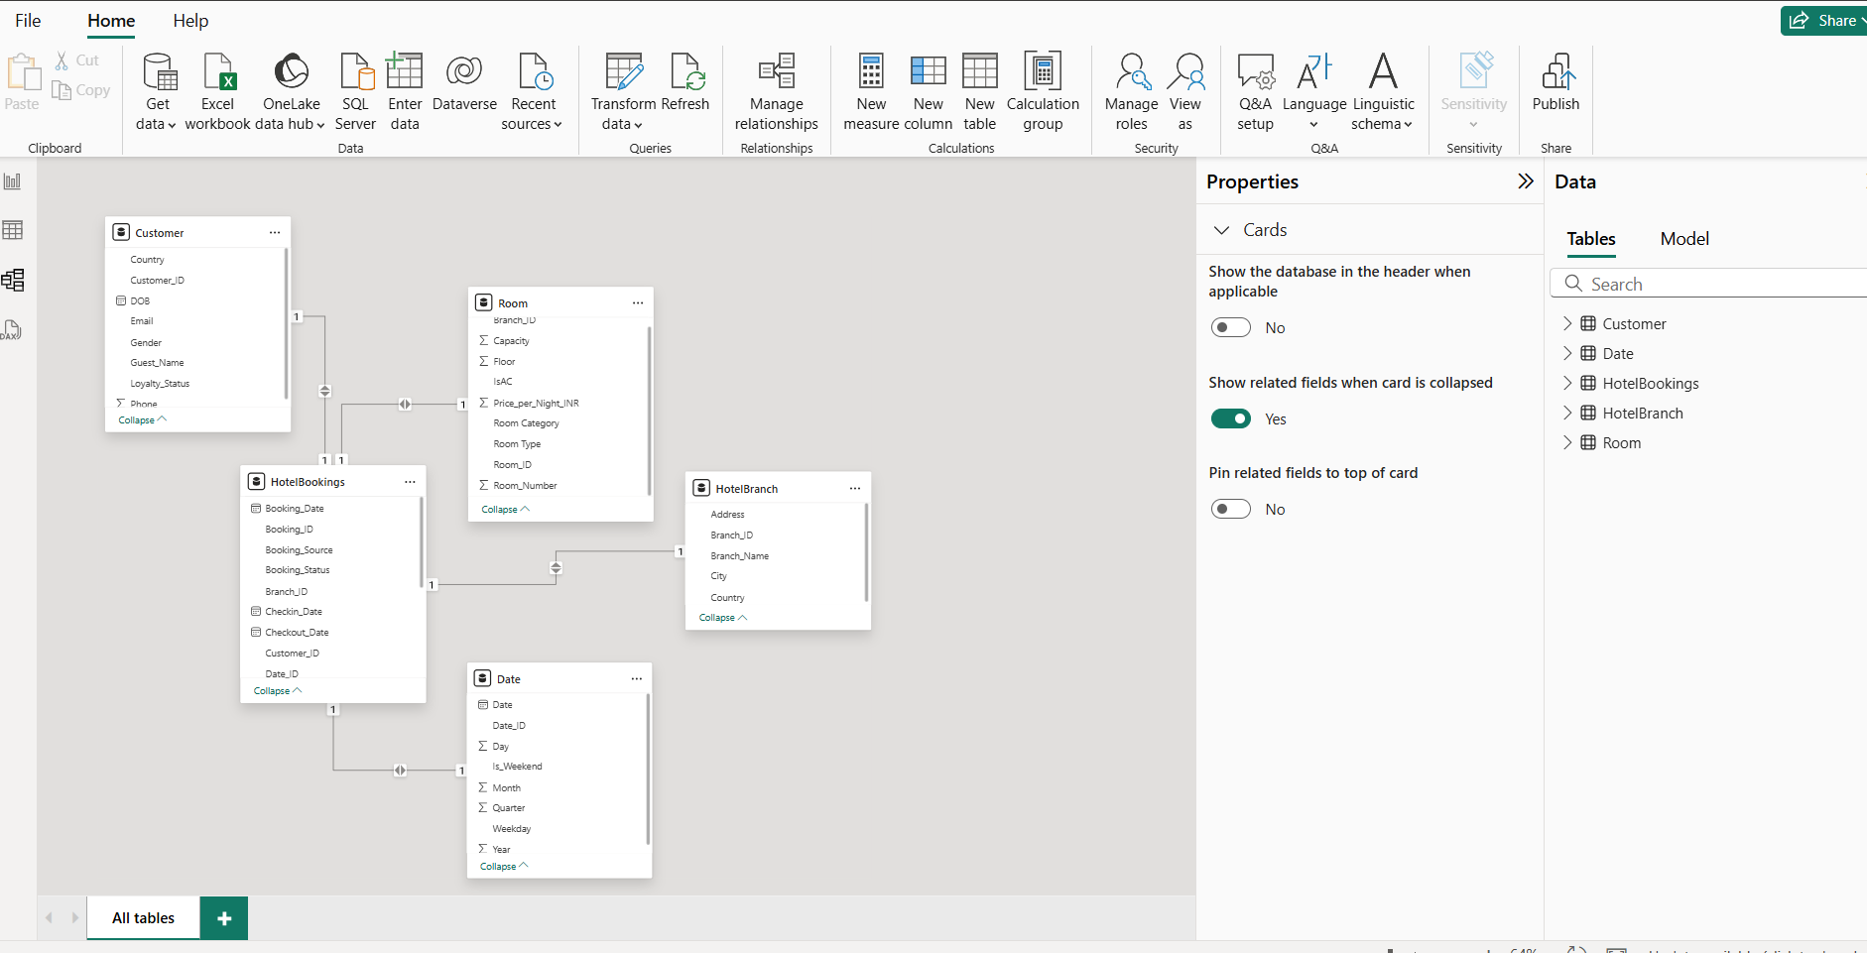

- Module 2: KPI Calculation and Performance Analysis
HotelRevAI focuses on creating a StayDate-based analytical model and calculating key revenue metrics like Occupancy %, ADR (Average Daily Rate), and RevPAR (Revenue per Available Room).
This module transforms the cleaned and modelled data from Module 1 into a daily, weekly, and seasonal performance dashboard using Power BI and DAX measures 1.
1.Creating the StayDate Column
To analyse room performance at a daily level, a StayDate column was generated.
The goal of this step is to expand each booking into individual dates between check-in and check-out — enabling accurate day-level tracking of occupancy and revenue.
Steps followed:
- In Power BI, open the Power Query Editor and select the table TblBooking.
- From the top menu, click on Add Column → Custom Column.
- Name the column StayDate.

- Insert the following formula:
= if [CheckInDate] <> null and [CheckOutDate] <> null then
List.Dates(Date.From([CheckInDate]), Duration.Days([CheckOutDate] - [CheckInDate]), #duration(1,0,0,0))
Else
Null
This formula creates a list of dates starting from the check-in date and ending at the check-out date for each booking.
Once expanded, each booking record represents a single day of stay, allowing daily-level insights.

2. Calculating Day-Level Revenue

After the StayDate column was created, the next step was to determine the DayRevenue (daily revenue for each stay).

Steps performed:

Select the columns — Booking_ID, Customer_ID, BranchID, RoomTypeID, CheckIn_Date, CheckOut_Date, Duration, Revenue, StayDate.

In Power Query, use Merge Queries to join TblBooking with TblRoom (where room rate is available).

Merge using RoomTypeID as the key field and select the corresponding room rate column.

After merging, expand the column to include the room rate and calculate DayRevenue by multiplying the duration by the room rate.

This step provides a granular revenue breakdown for each booking date and room category.

Developing DAX-Based KPIs
The transformed dataset was then imported back into Power BI, and a new table named TblCalculation was used to store DAX measures.
The first measure calculated was Total Revenue, defined as:
- TotalRevenue=CALCULATE(SUM('TblBooking_2'[DayRevenue]), FILTER('TblBooking_2','TblBooking_2'[StayDate]= TblCalculation[StayDate]))
This measure sums the daily revenue for each StayDate to compute the total earnings generated across all rooms for a specific date.

Next, the Occupancy Percentage was calculated using:
- Occupancy% = DIVIDE([Room Booked],[TotalRoom]) * 100
This formula measures what portion of available rooms were booked on any given day.

The Average Daily Rate (ADR) was then defined as:
- ADR = DIVIDE([TotalRevenue],[Room Booked])
ADR represents the average income earned per room that was occupied, reflecting the hotel’s pricing efficiency.

To understand overall revenue productivity, Revenue Per Available Room (RevPAR) was calculated as:
- RevPAR = DIVIDE([TotalRevenue],[TotalRoom])
This measure combines occupancy and pricing into one metric, showing the revenue generated per total available room, whether sold or vacant.

Additional DAX calculations were created to support time-based and seasonal analysis. The Season classification was generated using a conditional formula:
- Season = SWITCH(TRUE(), MONTH([StayDate]) IN {12,1,2},"Winter", MONTH([StayDate]) IN {3,4,5},"Spring", MONTH([StayDate]) IN {6,7,8},"Summer", MONTH([StayDate]) IN {9,10,11},"Autumn")
This automatically categorises each stay date into Winter, Spring, Summer, or Autumn based on its month.
Weekday
- Weekday = FORMAT([StayDate], "dddd")
Week

- Week = WEEKNUM([StayDate], 2)
Month Start

- Month Start = DATE(YEAR([StayDate]), MONTH([StayDate]), 1)
Month

- Month = FORMAT([StayDate], "MMMM")
Quarter

- Quarter = "Q" & FORMAT(ROUNDUP(MONTH([StayDate])/3,0), "0")
Year

- Year = YEAR([StayDate])
These DAX expressions together enabled detailed temporal segmentation and trend comparison across different time frames.
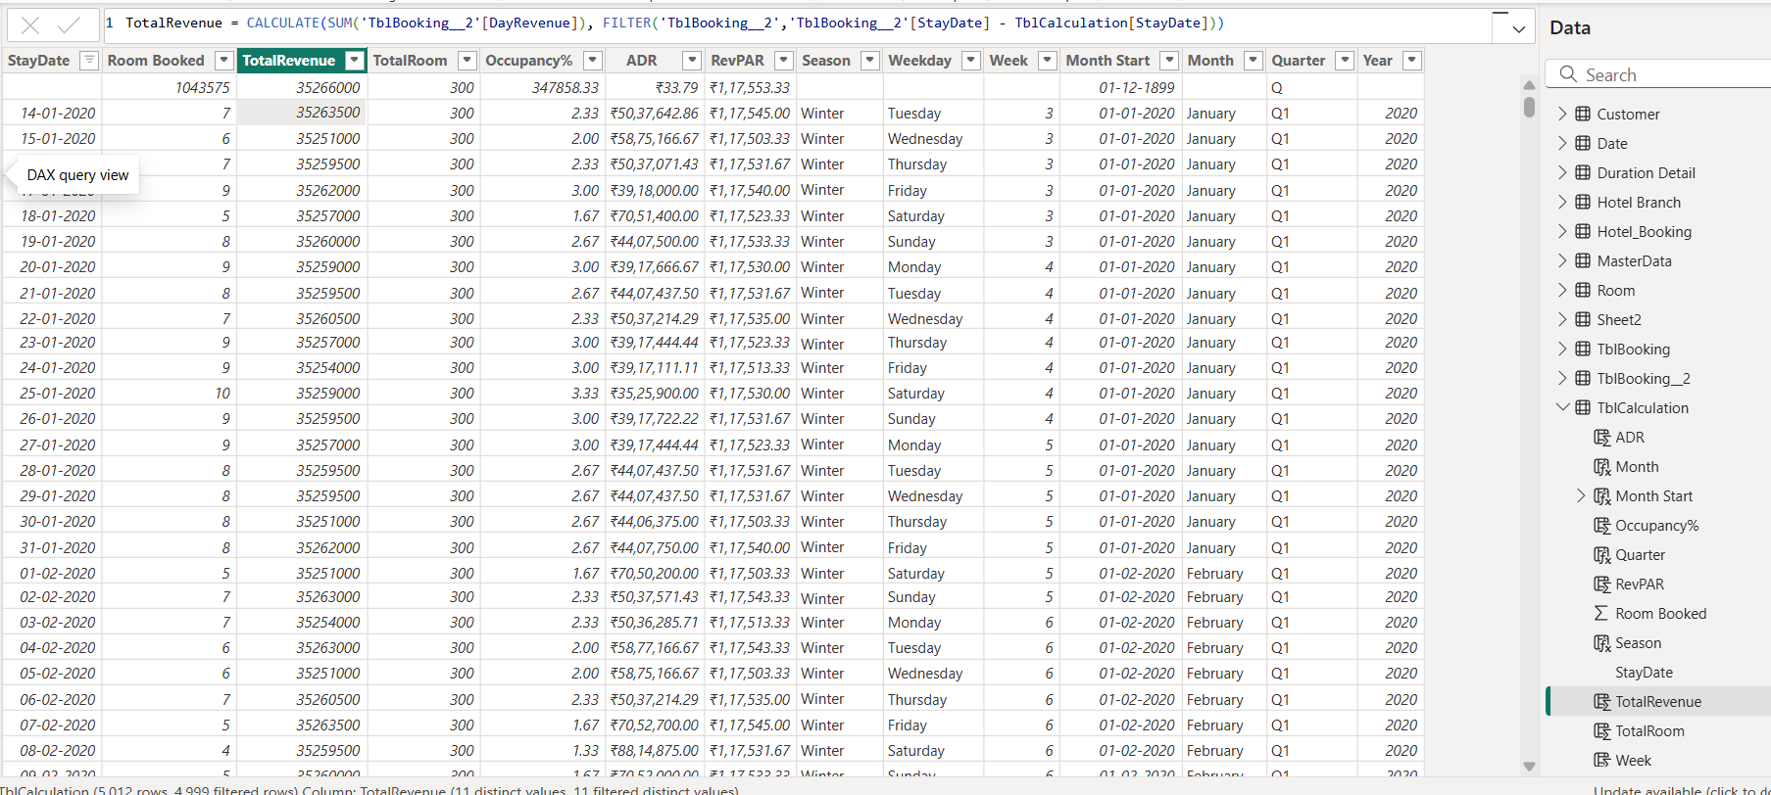

- Visualisation and Analysis

1️. Daily Trends – Line chart showing Occupancy %, ADR, and RevPAR by day. Helps track daily performance and demand patterns.

2️. Weekly Analysis – Bar chart comparing weekly Occupancy and Revenue. Highlights weekend peaks and steady growth.

3️. Seasonal Insights – Column chart showing revenue by season. Summer performs best; Spring shows an improvement scope.

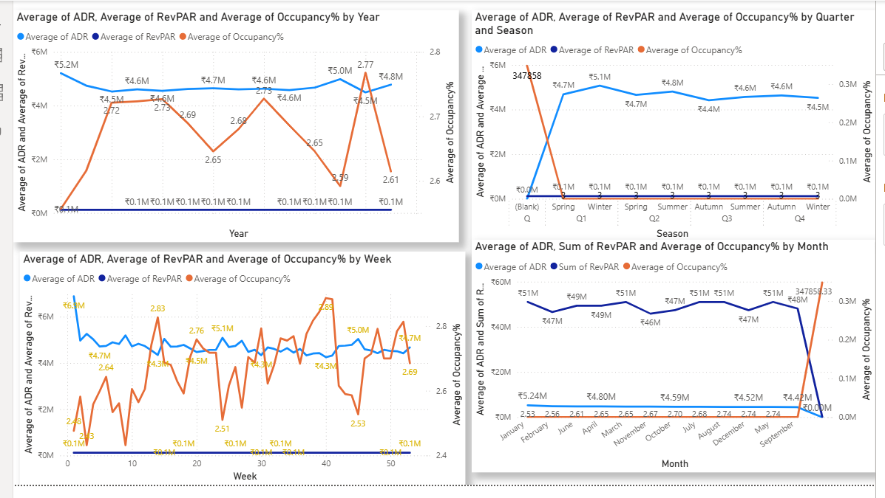

4️. Booking Channel Comparison – Donut chart comparing Direct vs OTA bookings. Direct gives higher ADR; OTA gives more volume.
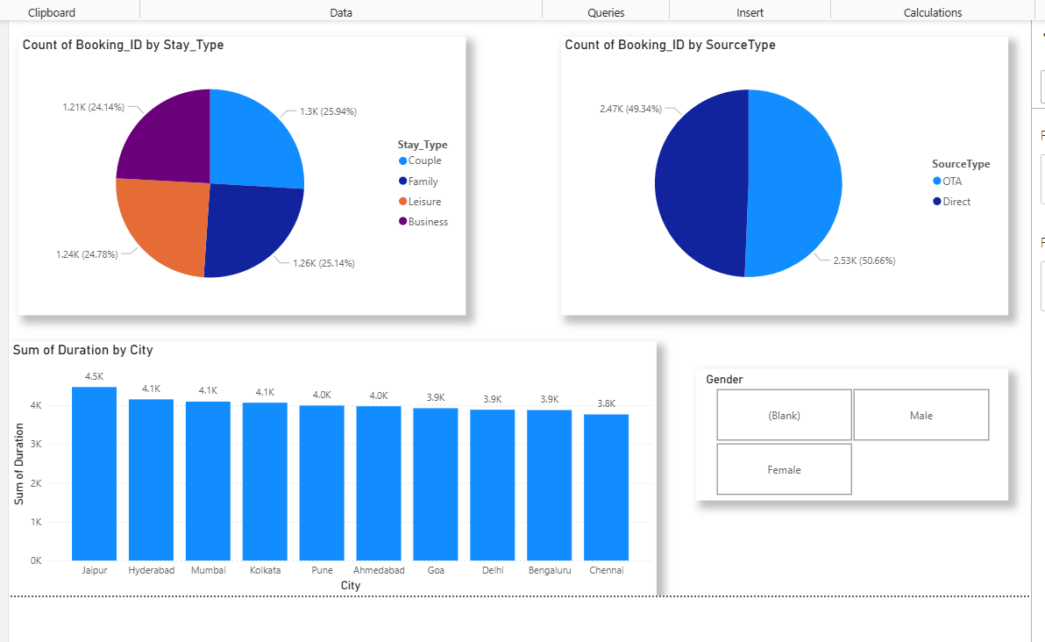

5️. KPI Summary Cards – Show key metrics:

Occupancy: ~72 %

ADR: ₹4.69 M

RevPAR: ₹117.53 K

Total Revenue: ₹51 M

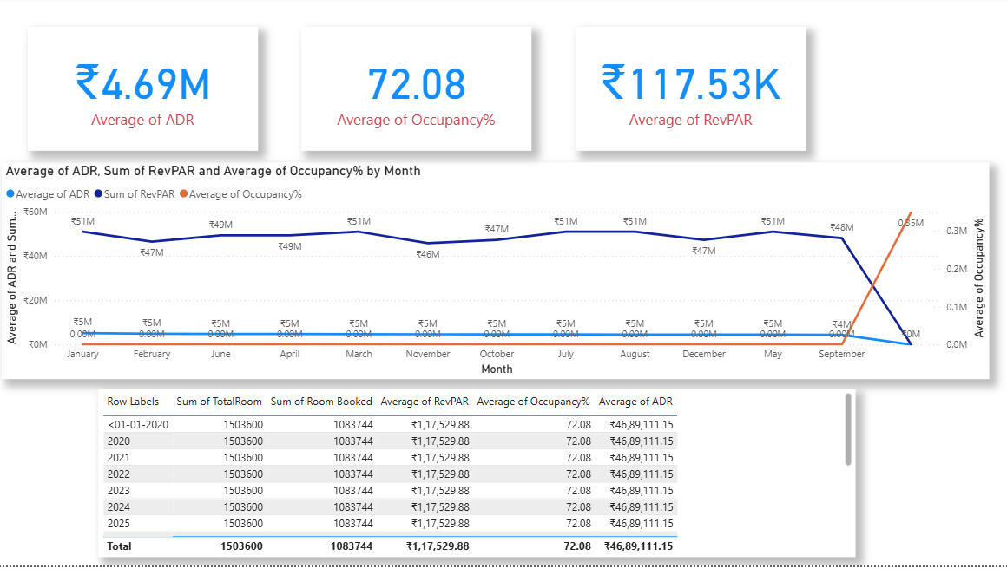

6️. Stay & Room Analysis – Pie charts for Stay Type and Room Type. Couple and Family stays dominate; Premium rooms earn the most revenue.

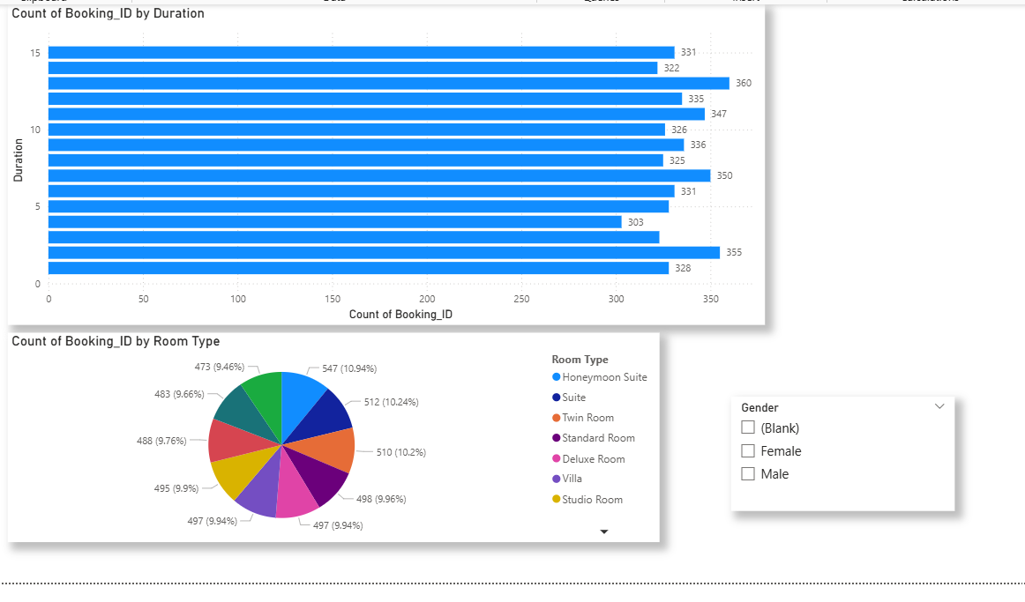

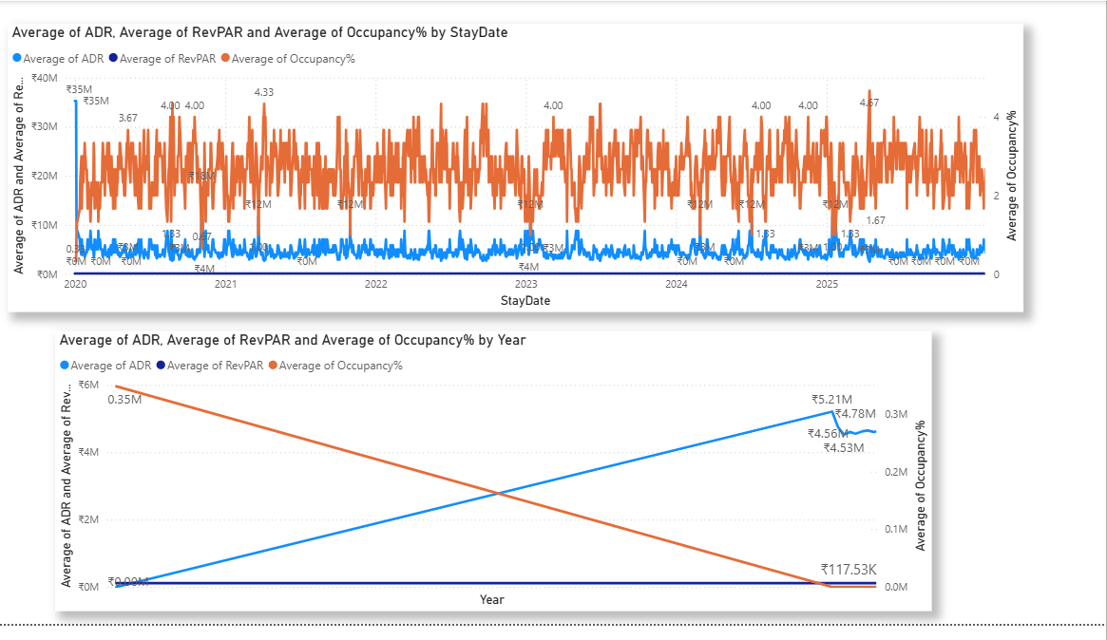

7. Insights and Findings Premium & Suite rooms generate the highest revenue, mainly during summer.

Occupancy peaks in December; March–April show lower demand.

Direct bookings via Website/App yield higher profits than OTAs.

Gold & Platinum customers contribute ~45% of total revenue.

Long stays and family bookings form a major part of annual income.

Urban branches perform better in ADR and RevPAR.

8 . Conclusion

HotelRevAI effectively transforms raw booking data into actionable insights using Excel, Power BI, Power Query, and DAX.
It helps hotel management track occupancy, pricing, and customer behaviour across branches and time periods.
The system supports dynamic pricing, marketing optimisation, and revenue growth, showcasing how data-driven intelligence can enhance hotel performance.

